**PRACTICAL 5**

**Aim:** Perform a BLAST search on a specific gene sequence of a specify organism.

**Steps:**

1. Go to the National Center for Biotechnology Information Site https://www.ncbi.nlm.nih.gov/

Select Nucleotide from All Databases and find any organism in a search bar.

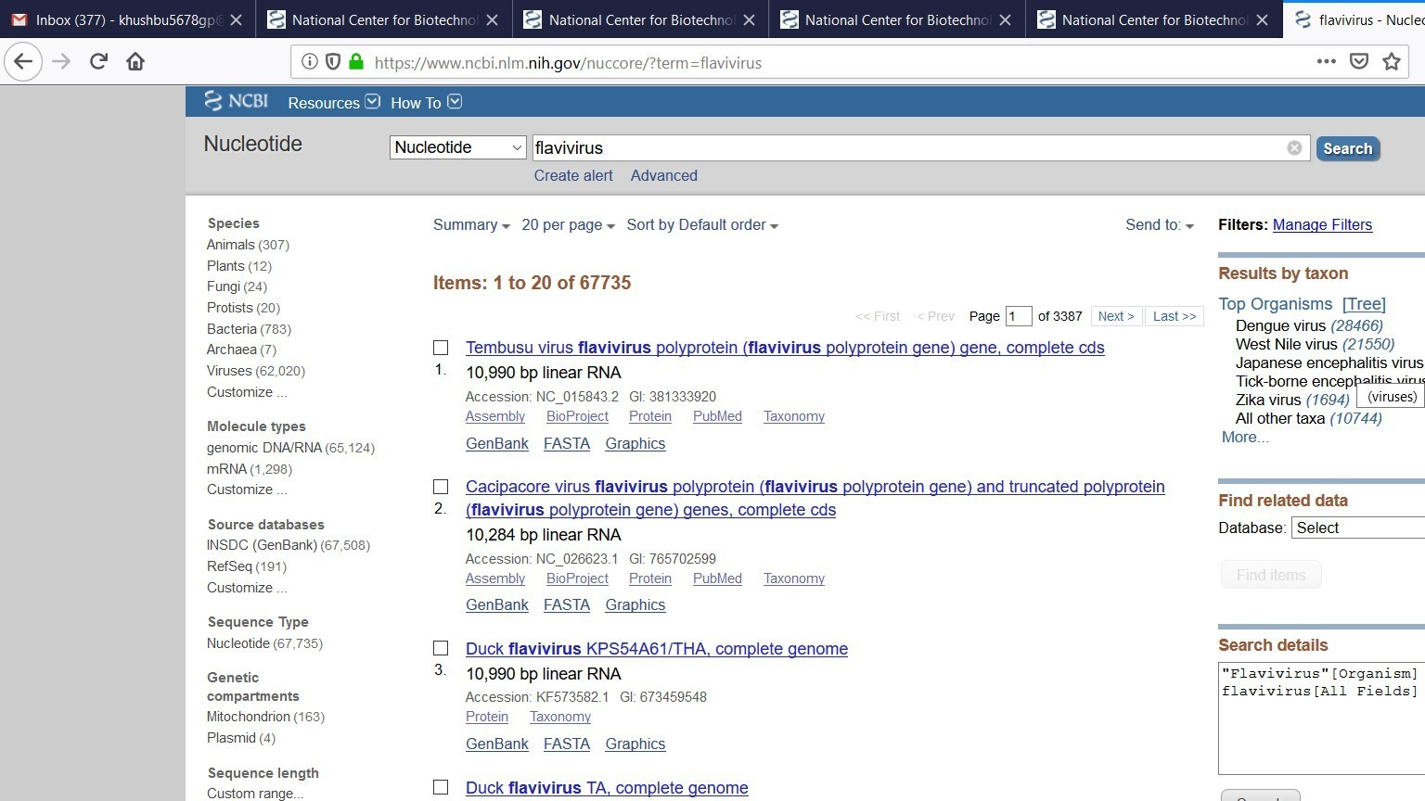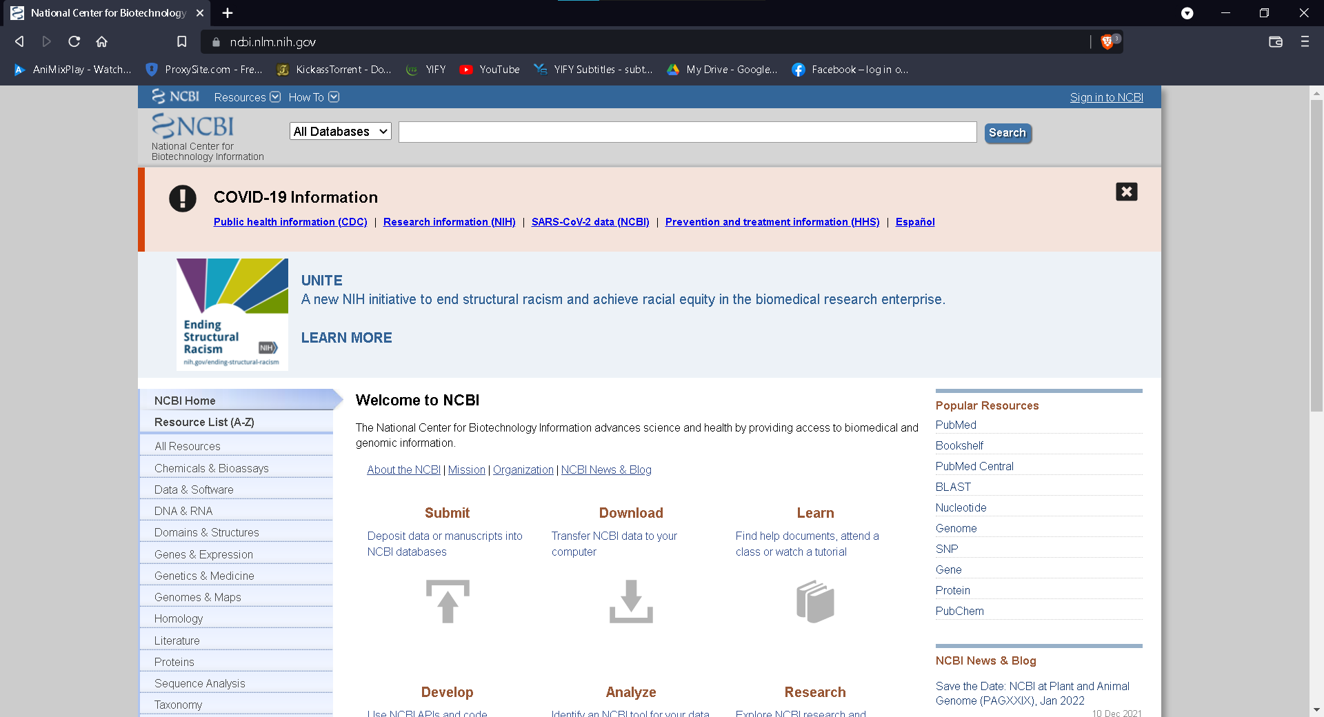

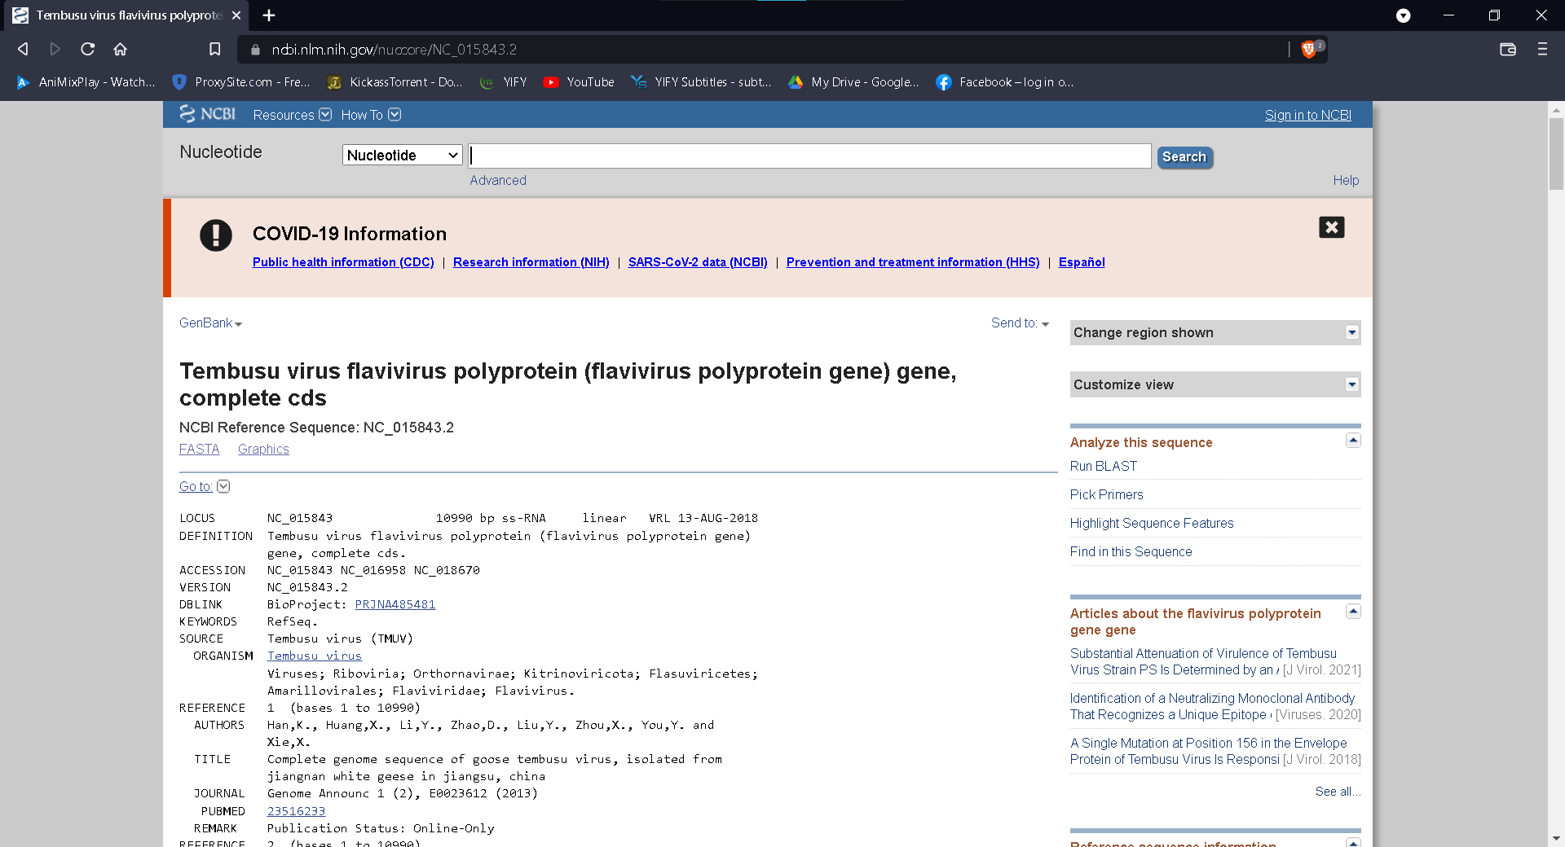

1. 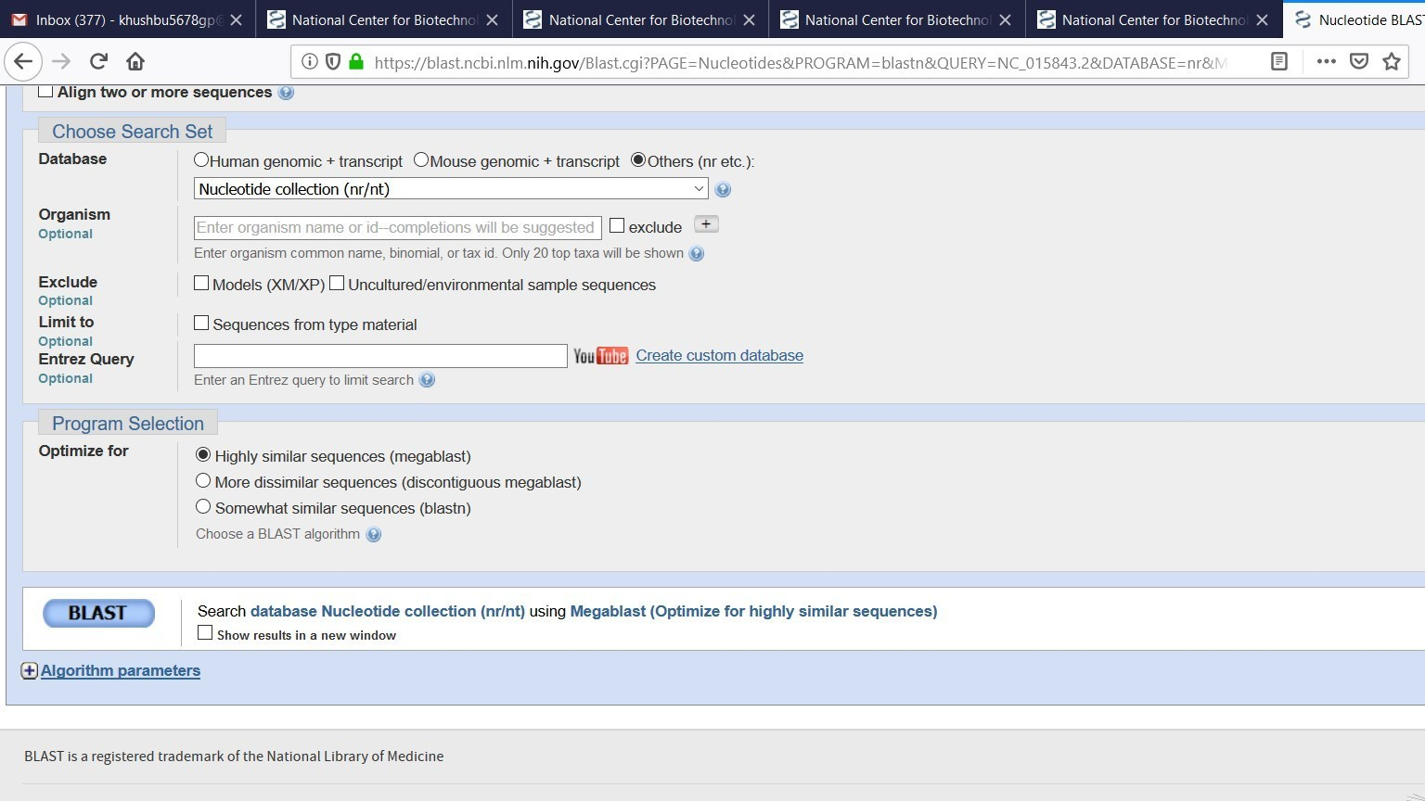Run BLAST option we have to select
2. BLAST

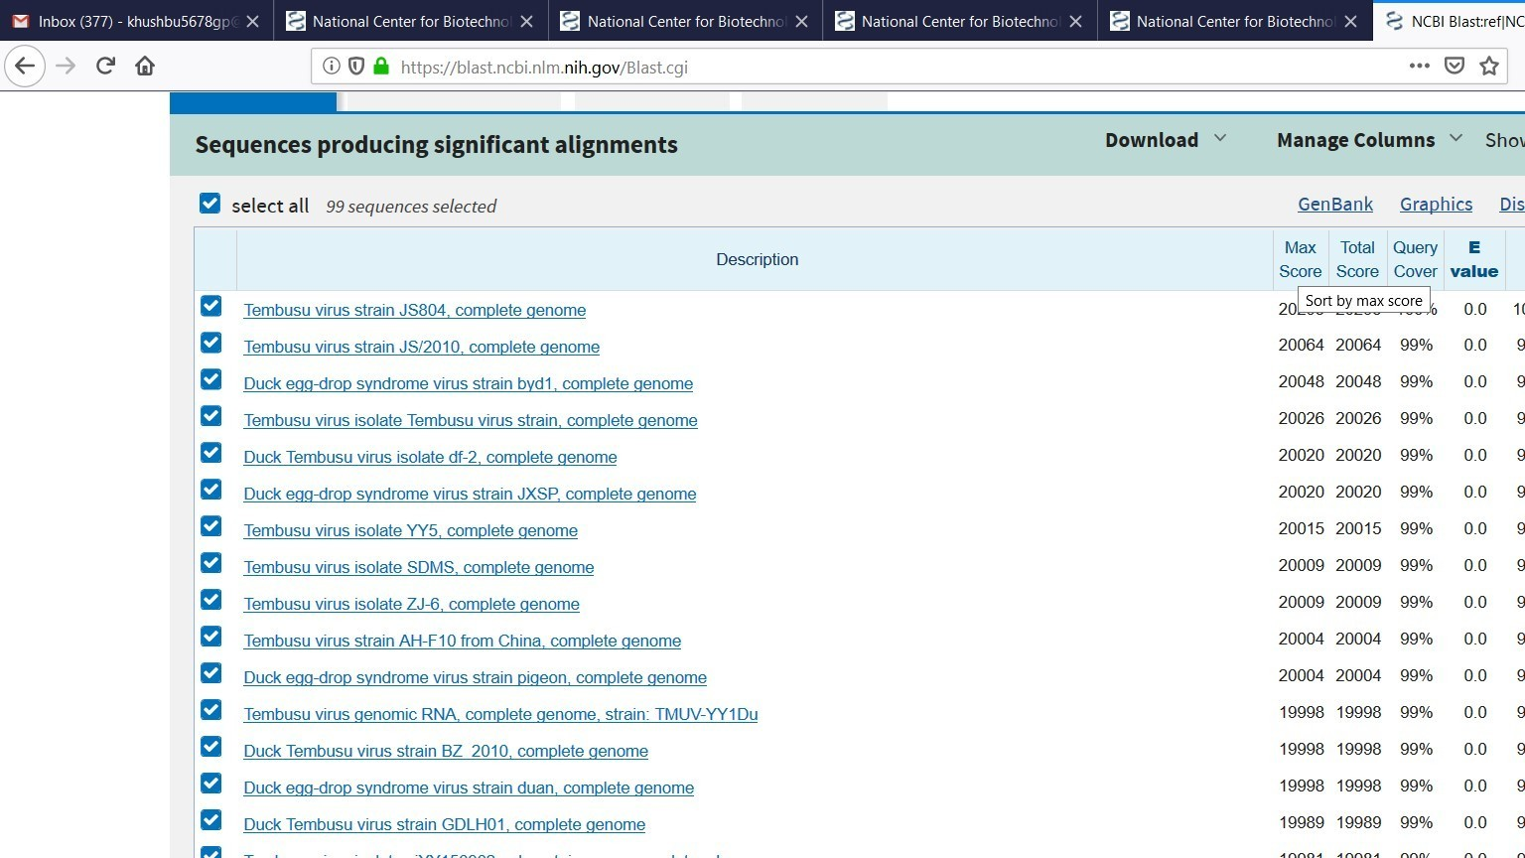

1. 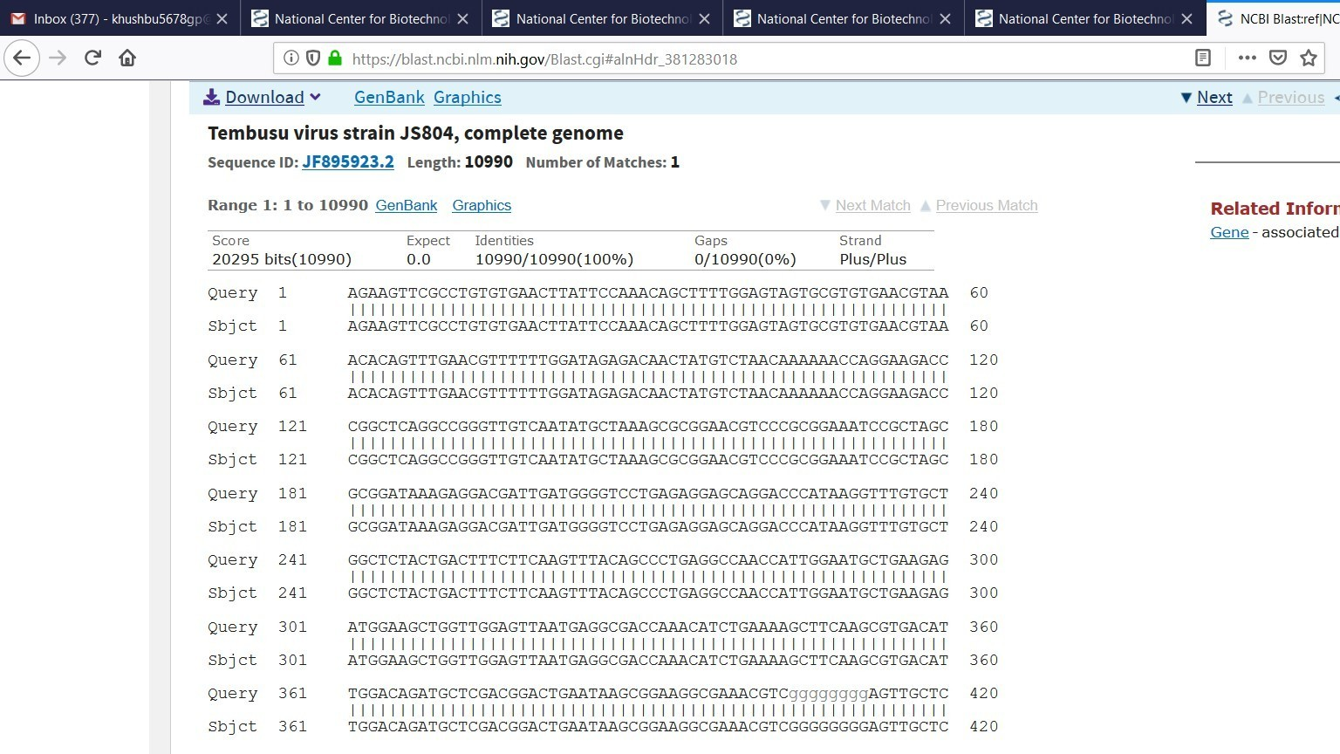Here the result will be display